**4. Installing and Configuring WS Services**

UNIVERSITY OF INFORMATION TECHNOLOGY – VNU-HCM

**FACULTY OF COMPUTER NETWORKS AND COMMUNICATIONS**

**PHỤC VỤ MỤC ĐÍCH GIÁO DỤC**

FOR EDUCATIONAL PURPOSE ONLY

**NETWORKS AND SYSTEMS ADMINISTRATION LABS**

**(V09.2022)**

# OVERvIEW

## Learning objective

In this lab, students will practice with common services on Windows Server:

* Installing and configuring the DNS and DHCP.
* Deploying the IIS Web Server and FTP Server.
* Deploying the Mail Services with Mail Exchange and configuring mail policies.

## Practice Environment

Students need to prepare at least the following:

* **Two VMs** that installed Windows Server 2019 works as Server.
* **A VM** that installed Windows OS (Windows 7, 8, 10, or Server) works as Client.

It will help if you use VMWare or VirtualBox to have the necessary VMs listed above. We recommend choosing the newest stable version of the OS to reach more recent functions and features.

|  |  |  |  |
| --- | --- | --- | --- |
|  | **IP Address** | **DNS** | **Operating System** |
| Server 1 | 192.168.1.5 / 24 | 192.168.1.5 | Windows Server 2019 |
| Server 2 | 192.168.1.6/24 | 192.168.1.5 | Windows Server 2019 |
| Client | DHCP  *or*  192.168.1.20/24 | DHCP | Windows 7,8,10, or newer |

Table 1: The information of VMs

For all VMs required to install the Windows Server version, you should choose the ***DataCenter Evaluation (Desktop Experience)*** option to have a full Windows graphical environment.

# Lab tasks

## Kick-off

|  |
| --- |
| Why do we need DNS, DHCP, FTP, and Mail service? Is the network system working correctly without these services? |

## DNS Service

In this task, we need to use two VMs (a Server and a Client). We will install the Windows Server 2019 (or newer) on the Server and Windows OS (7,8,10, or more recent) on the Client. You need to refer IP addresses for these VMs in Table 1.

|  |
| --- |
| **Server 1:**   1. Assign the corresponding IP address for the network interface *(refer to Table 1)* 2. Change the *Primary DNS Suffix* to **groupX.local** *(X is your group ID),* and the *Computer Name* to **ser01** 3. Install and configure the DNS service. Configure the Primary Zone **groupX.local** on the *Forward Lookup Zone* and *Reverse Lookup Zone.* 4. Create DNS records on both Forward Lookup Zone and Reverse Lookup Zone for hosts below:  * ser01.groupX.local 🡪 192.168.1.5 * dns.groupX.local 🡪 ser01.groupX.local * groupX.local 🡪 192.168.1.5 * mmt.groupX.local 🡪 dns.groupX.local |

|  |
| --- |
| **Client:**   1. Assign the corresponding IP address for the network interface *(refer to Table 1).* Then use the ***nslookup*** command to retrieve the DNS information *(you need briefly explain the result in your report)*  * groupX.local * mmt.groupX.local * 192.168.1.5 * nc.groupX.local |

## DHCP Service

Please note that you must disable all DHCP services provided by VMWare, VirtualBox, or your network before conquering this task!

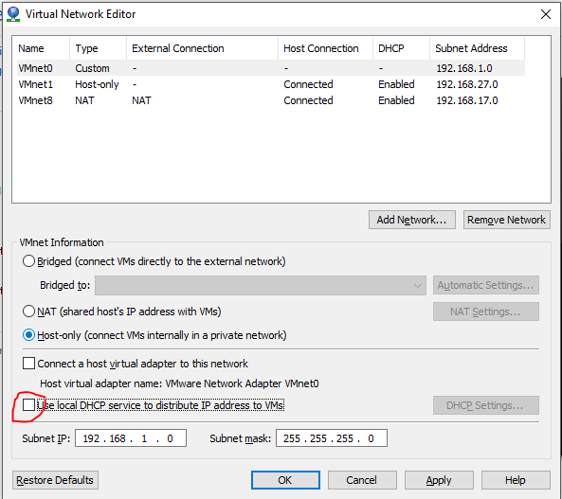

Figure 1: Disable the DHCP service when using VMWare

|  |
| --- |
| **Server 1:**   1. Add the “DHCP” feature. 2. Create a new "DHCP scope" if it does not exist. Then configure this scope with the following information:  * IPs pool: 192.168.1.100 🡪 192.168.1.200 * Subnet mask: 255.255.255.0  1. Configure the DHCP server so that client will receive the information of the Default Gateway and DNS server when the client obtains a new IP address. 2. Exclude the IP between 192.168.1.180 and 192.168.1.190 from being leased. |

|  |
| --- |
| **Client:**   1. Configure the Client that automatically obtains a new IP address and relevant information (such as Default Gateway, DNS server,…) when joining to the network. |

## Web Service (IIS) and FTP server

|  |
| --- |
| **Server 1**   1. Create new DNS records for all hostnames below:  * ser02.groupX.local 🡪 192.168.1.6 * www.groupX.local 🡪 ser02.groupX.local * [ftp.groupX.local](ftp://ftp.groupX.local) 🡪 ser02.groupX.local |

|  |
| --- |
| **Server 2**   1. Change the *Computer Name* to **ser02**. Assign the corresponding IP address for the network interface *(refer to Table 1).* 2. Install the “*Internet Information Service – IIS”* and "*FTP Server"* services. 3. From the IIS Manager, create an FTP site and host it on C:\FTP. It will be binding on port 21. |

|  |
| --- |
| **Client:**   1. Open web browser and access the website http://www.groupX.local and <ftp://ftp.groupX.local>. 2. Use an FTP Client application (e.g., FileZilla, WinSCP,…) to upload and manage resources on the FTP server through FTP protocol. |

## Mail Server

The newest stable version of Microsoft Mail Exchange is recommended. You can choose the older version if your computer does not meet the installation requirements.

|  |
| --- |
| **Server 2**   1. Install the Microsoft Mail Exchange service. The *Domain name* for email is **groupX.local** (*X is the group ID*). 2. Create the appropriate DNS records on Server 1 to send and receive emails; and access the management portal through domain name instead of IP address. 3. Create new email accounts [report@groupX.local](mailto:report@groupX.local), [student1@groupX.local](mailto:student1@groupX.local), and [student2@groupX.local](mailto:student2@groupX.local) . Try sending a new email from student1 to student2. 4. Use a Mail Client (e.g., MS Outlook, Thunderbird) to access and manage your mailbox, as well as send or receive emails. 5. Design and implement policies on Mail Server to:    * Limit the size of attachment files to 1MB.    * Automatically forward email to [report@groupX.local](mailto:report@groupX.local) if it contains the encrypted .ZIP file.    * Automatically drop emails that contains special keyworks (e.g., *"username"*, "*password"*,…). |
|  |

# Requirements

You are expected to complete all tasks in section B (Lab tasks). Advanced tasks are optional, and you could get bonus points for completing those tasks. We prefer you work in a team of four to get the highest efficiency.

Your submission must meet the following requirements:

* You need to submit a **detailed lab report in .docx** *(Word Document)* format, **using the** **report template** provided on the UIT Courses website.
* Either Vietnamese or English report is accepted, that’s up to you. The report written in the mixing of multiple languages is not allowed (except for the untranslatable keywords).
* When it comes to **programming tasks** *(require you to write an application or script),* please attach all source-code and executable files (if any) in your submission. Please also list the important code snippets followed by explanations and screenshots when running your application in your report. Simply attaching code without any explanation will not receive points.
* Submit work you are proud of – don’t be sloppy and lazy!

Your submissions must be your own. You are free to discuss with other classmates to find the solution. However, copying reports is prohibited, even if only a part of your report. Both reports of the owner and the copier will be rejected. Please remember to cite any source of the material (website, book,…) that influences your solution.

|  |
| --- |
| **Notice:** Combine your lab report and all related files into a single **ZIP file (.zip)**, name it as follow:  ***StudentID1_StudentID2_ReportLabX.zip*** |